**Warehouse Space Utilization Analysis**

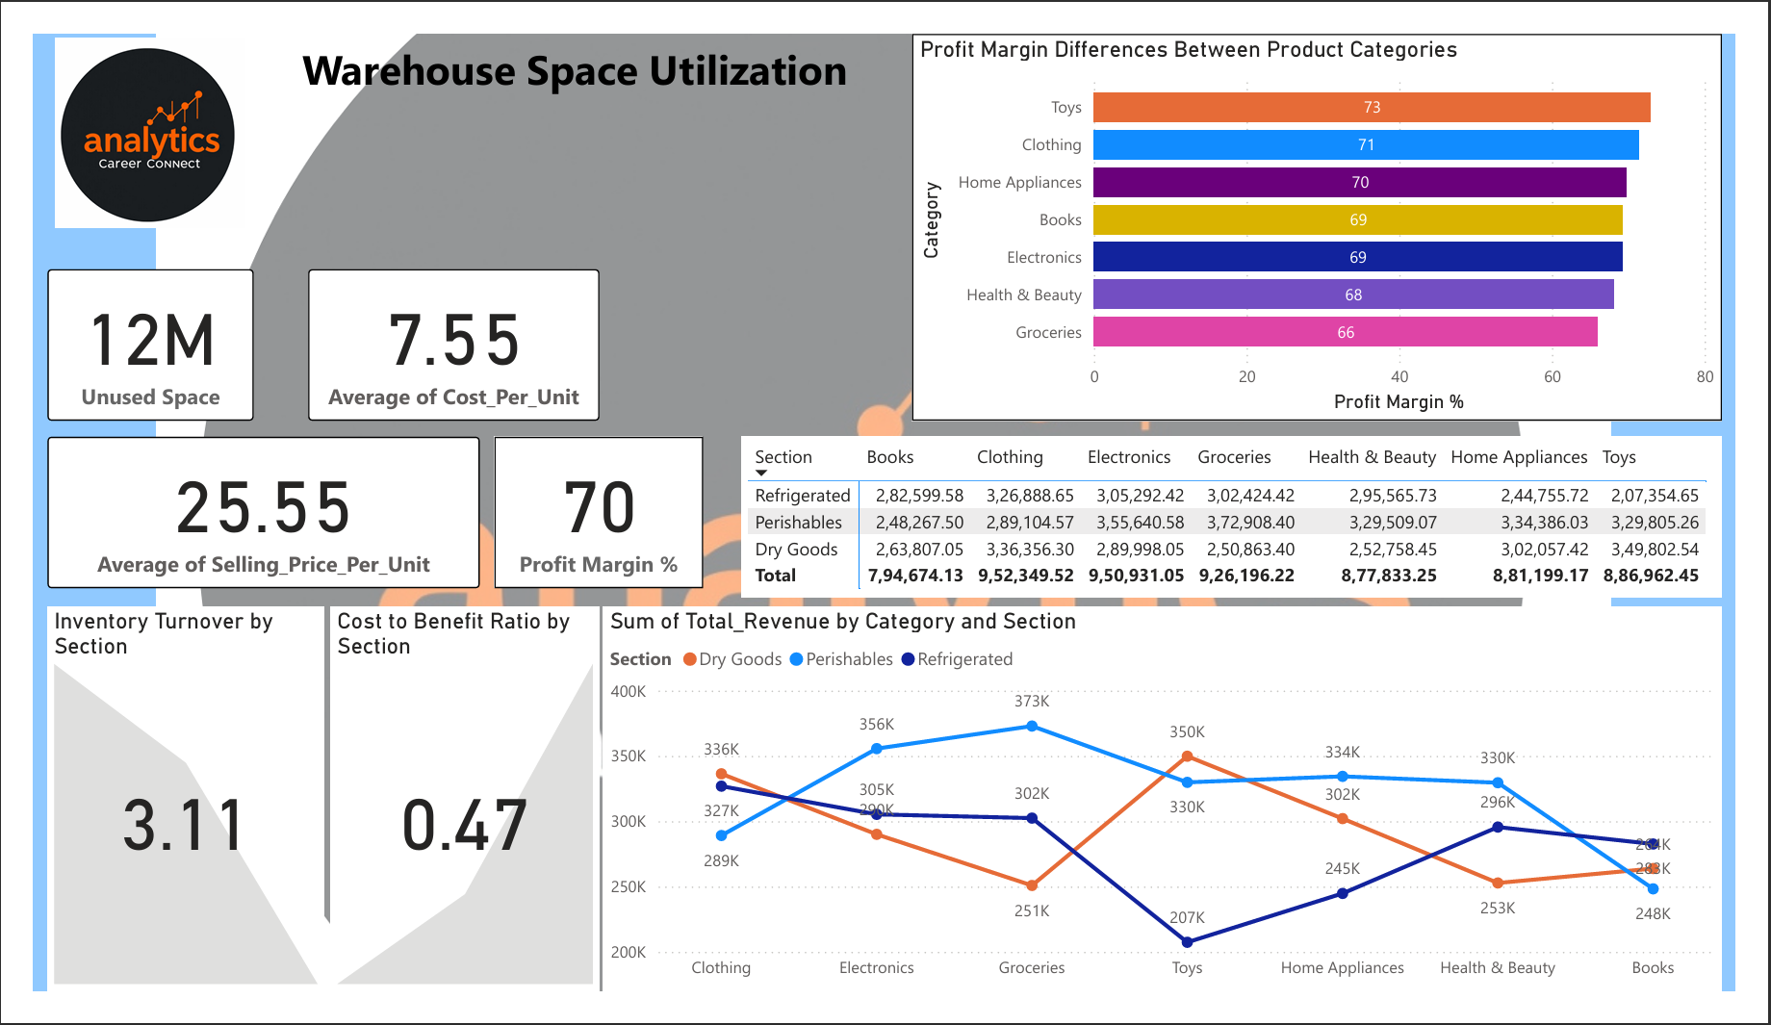  
  
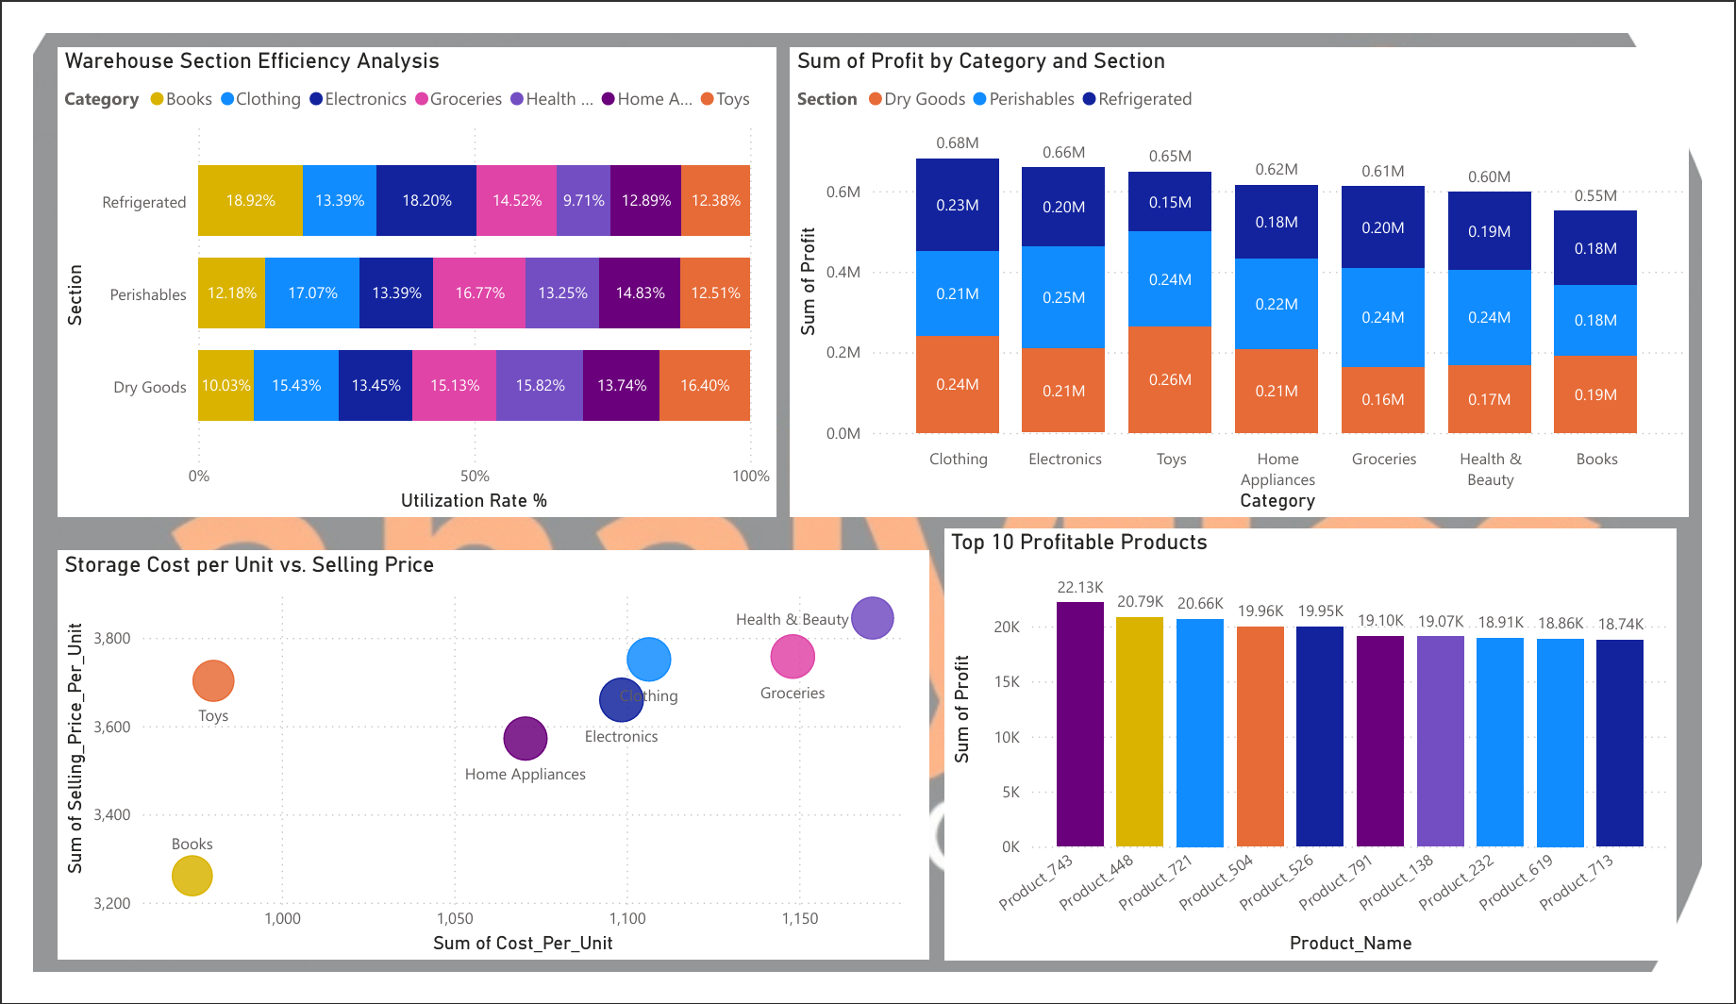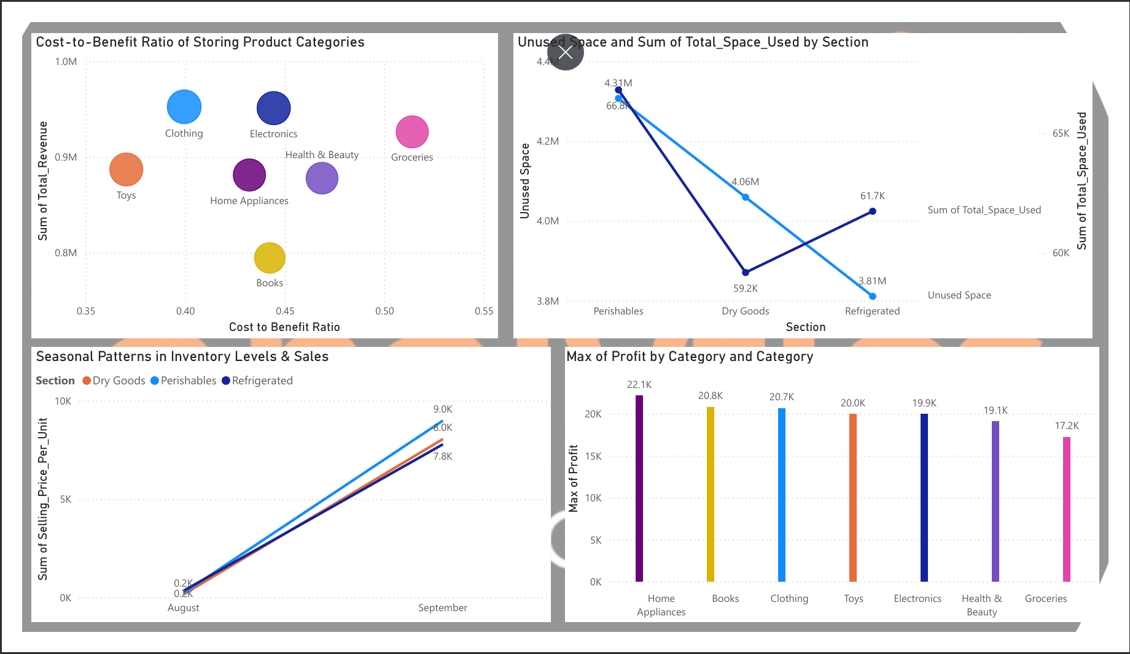  
  
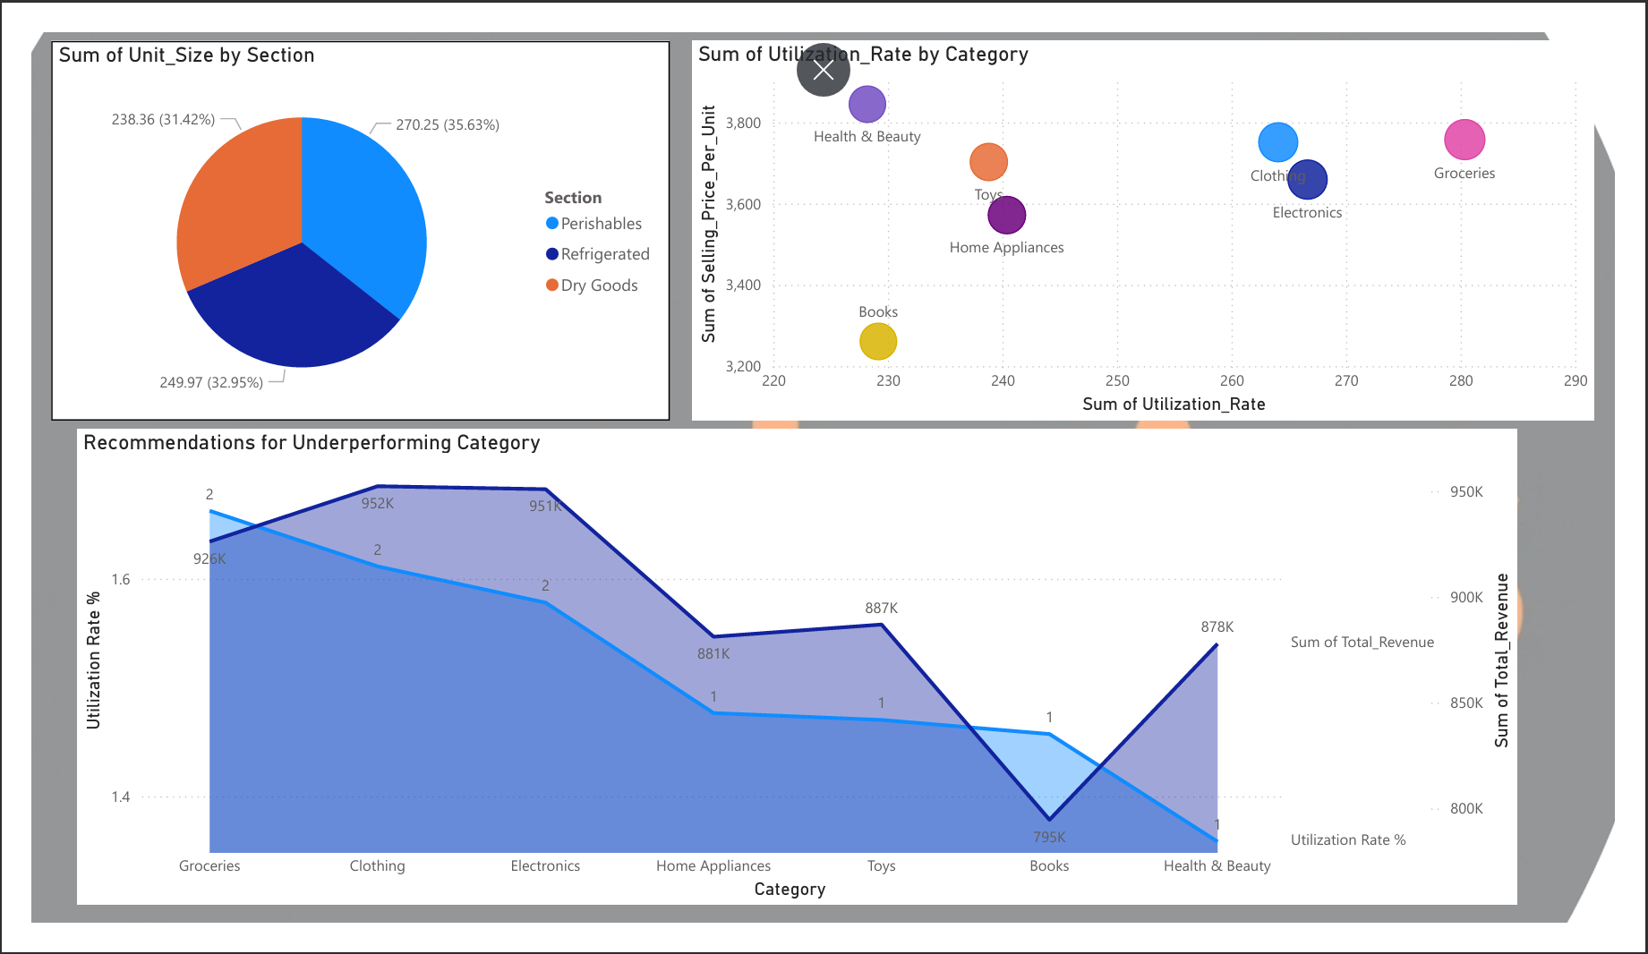

**Insights**

1. **Profitability & Cost Analysis:**

* **Profit Margins Across Categories:**
  + 1. Highest in **Toys (73%)** and **Clothing (71%)**.
    2. **Electronics, Books, and Home Appliances** have similar profit margins (~69-70%).
    3. **Health & Beauty (68%)** and **Groceries (66%)** are slightly lower.
* **Top 10 Most Profitable Products:**
  + 1. **Product_7** leads with **22.13K** profit.
    2. The top 10 products generate profits between **18.74K - 22.13K**.
* **Cost-to-Benefit Ratio:**
  + 1. The ratio is highest for **Clothing and Groceries**.
    2. **Health & Beauty** and **Books** have lower cost efficiency.
* **Storage Cost vs. Selling Price:**
  + 1. **Electronics and Toys** have a **higher selling price** relative to cost.
    2. **Books and Groceries** have **lower margins** due to higher storage costs.

1. **Warehouse Utilization & Space Efficiency:**

* **Overall Warehouse Space Utilization:**
  + 1. **12M** of warehouse space is **unused**, indicating inefficiencies.
    2. **Utilization Rate** is highest in **Refrigerated (18.92%)**, followed by **Perishables (17.07%)** and **Dry Goods (10.03%)**.
* **Warehouse Space by Section:**
  + 1. **Refrigerated section** has **4.06M total space** but a lower **59.2K utilized**.
    2. **Perishables (4.31M total, 66.8K utilized)** show higher space usage.
    3. **Dry Goods (3.81M total, 61.7K utilized)** has the lowest space allocation.
* **Inventory Turnover:**
  + 1. **3.11 turnover rate**, meaning inventory moves at a moderate pace.

1. **Revenue & Sales Trends:**

* **Total Revenue by Category & Section:**
  + 1. **Clothing (952K)** and **Electronics (950K)** generate the highest revenue.
    2. **Groceries (926K)** follows closely.
    3. **Books (887K)** and **Health & Beauty (878K)** are on the lower end.
* **Seasonal Sales Trends:**
  + 1. **Sales peak in August & September**, suggesting seasonal demand.
    2. **Refrigerated and Perishables** categories see more fluctuation.

1. **Recommendations for Improvement:**

* **Optimize Space Utilization:**
  + 1. Reduce **unused space** (12M) by improving allocation.
    2. Increase **utilization rates** in Dry Goods (only 10.03%).
* **Improve Low-Profit Categories:**
  + 1. Focus on optimizing **Groceries (66% margin)** by reducing storage costs.
    2. **Books (69% margin)** should be reconsidered for storage efficiency.
* **Boost High-Profit Items:**
  + 1. Prioritize **Toys and Clothing** in stock replenishment.
    2. Leverage **seasonal demand patterns** for Electronics and Home Appliances.
* **Enhance Inventory Turnover:**
  + 1. Strategies like demand forecasting & dynamic pricing to move slow-moving items faster.